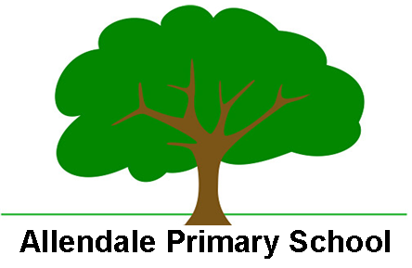

Enabling and Adapting the R.E. Curriculum
At Allendale Primary School we are able to support SEND and less experienced learners in the Religious Education curriculum on a personalised approach that can include:
- Pre – teaching of topic vocabulary
- Pre-teaching/Pre reading of topic content
- Pre-exposure to lesson content/equipment to engage interest
- Use of hooks to engage visual learners e.g model, picture, object
- Focus on oracy – well managed environmental background noise
- Use of a therapeutic classroom to create a calm learning environment
- Visual prompts and organisers
- Personalised vocab mat
- Sentence stems
- Opportunities for repetition and over learning
- Mixed ability peer pairings/groupings/flexible groupings
- Dyslexia friendly strategies for reading and writing
- Modelled ‘thinking out loud’ to scaffold thought processes
- Adult scaffolding to further break down tasks and learning into smaller steps
- Worked examples to use as a model
- Scaffolded recording e.g use of scribe or video recording/word processing tool, writing frames
- Adaptations to resources e.g enlarged diagrams/additional labelling
- Use of real life references to make content less abstract – supported by pictoral/video resources
- Growth mindset approach to evaluating work and that of others
- Use of real life resources e.g topic boxes
- Use of real life experiences e.g school visits/visitors into school
- Inclusion of drama/hot seating/role play
- Use of scrap books/video to record discussions/individuals input
- Use of scrap books to support ‘remembering more’

