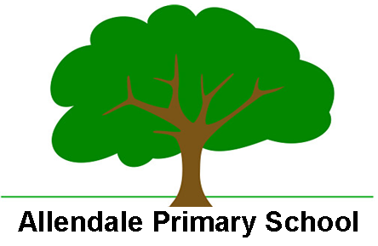

Enabling and Adapting the P.E Curriculum

PE helps pupils develop personally and socially. They work as individuals, in groups and in teams, developing concepts of fairness and of personal and social responsibility.

At Allendale Primary School we are able to support SEND and less experienced learners in the P.E/Outdoor learning curriculums on a personalised approach that can include:

- Use of learners preferred methods of communication e.g simplified instructions, use of symbols, visual tools
- Careful consideration of the environment to mitigate any barriers to learning from accessibility
- Adaptations to tasks
- Adaptations to equipment – e.g to size, weight and grip of equipment.
- Peer support
- Adult scaffolding e.g additional modelling of skills
- Skills teaching broken into smaller steps
- Use of sensory/rest breaks
- Pre-teaching of topic vocabulary
- Low stakes activities – peer talk/small group games

