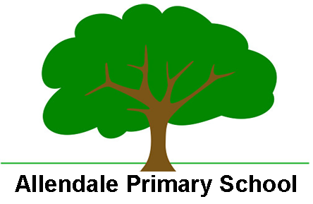

Enabling and Adapting the Reading Curriculum

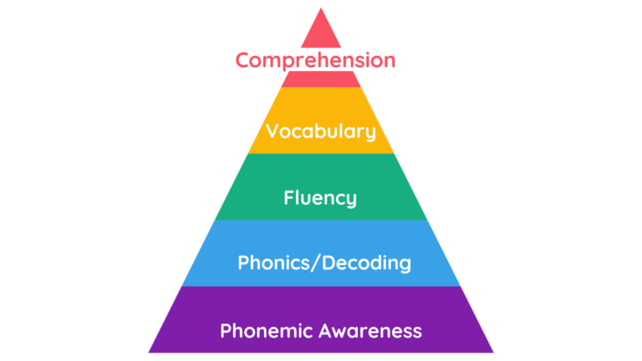

At Allendale Primary School we are able to support SEND and less experienced learners in the Reading curriculum on a personalised approach that can include:

- Immersion in stories/rhymes, songs and poems to support language development
- Support for recording comprehension tasks
- RWI grouping throughout school – vertical grouping may be appropriate
- Regular assessment and flexible phonics grouping
- Revise, teach, practise, apply approach
- Lots of opportunities to hear, say, read and spell phonemes
- Segmenting and blending modelled through everyday routines
- Segmenting and blending modelled throughout the curriculum
- Displays and personal phoneme charts
- Use of concrete resources – magnetic letters, word building games
- Application of sound buttons in texts across curriculum areas
- Use of phonic matched reading scheme books to build fluency and confidence
- Explicit teaching of comprehension skills e.g. asking questions/drawing inferences/predicting or summarising
- CEW peer tutoring intervention
- Additional small group or 1:1 RWI intervention
- Pre-exposure to classroom texts
- Use of hooks to engage visual learners e.g model, picture, object
- Focus on oracy – well managed environmental background noise
- Visual prompts and organisers
- Opportunities for repetition and over learning
- Modelled ‘thinking out loud’ to scaffold thought processes
- Adult scaffolding to further break down tasks and learning into smaller steps.

