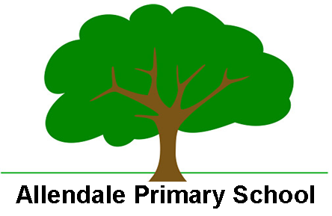

Enabling and Adapting the PSHE Curriculum

At Allendale Primary School we are able to support SEND and less experienced learners in the PSHE curriculum with a personalised approached which can include:

- Use of therapeutic Classroom approach and calming environment
- Pre – teaching of topic vocabulary
- Pre-teaching/Pre reading of topic content
- Focus on oracy – well managed environmental background noise.
- Visual prompts and organisers
- Personalised vocab mat
- Sentence stems
- Whole school implementation of the Zones of Regulation
- Staff modelling of emotions and problem solving
- Friends Resilience curriculum
- Use of social stories
- Use of range of fiction to support themes
- Building on prior knowledge
- Adapting teaching according to personal experiences or situational events
- Mixed ability peer pairings/groupings/flexible groupings
- Dyslexia friendly strategies for reading and writing
- Adult scaffolding to further break down tasks and learning into smaller steps.
- Use of the outdoor environment for learning.
- Role play/hot seating/drama
- Use of IT to record learning
- Anti bullying initiative and inclusion in anti bullying ambassador programme
- Involvement in workshops
- Different ways to report concerns - written, picture, HT red furry box, anti bullying box
- Lego group interventions and support
- Friendship and social group intervention and support
- Access to extra curricular clubs

