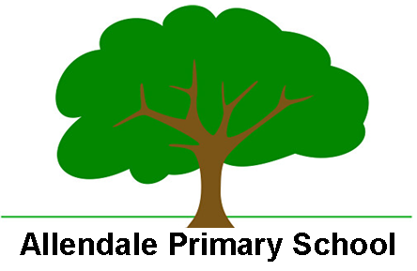
Enabling and Adapting the Early Years Curriculum

At Allendale Primary School we are able to support SEND and less experienced learners in the music curriculum with a personalised approached which can include:

- Pre - teaching of topic and genre related vocabulary
- Pre - exposure to lesson content to engage interest
- Connect / link - transference of ideas, skills, concepts real life situations and prior learning
- Use of hooks to engage visual learners e.g. instruments, videos etc.
- Use of therapeutic classrooms to create calm environment
- Adult to be explicit language for instructions
- Stem sentences
- Use videos, photographs, visual resources and real objects as well as and language e.gs to support during learning across all curriculum where possible/necessary
- Mixed ability peer pairings / groupings
- Modelled ‘thinking out loud’ to scaffold creative activities and problem solving
- Adult modelling of use of resources and to express ideas
- Encourage experimentation and exploration
- Sharing ideas via peer modelling
- Use of ear defenders, cuddly blankets etic
- Visual aids in the form of worked examples
- Peer evaluation of work and supportive feedback
- Adult scaffolding / support to break tasks down into smaller steps
- Use of outdoor environment
- TA support

